**COVID -19 VACCINE ANALYSIS**

Phase 5 submission document

**612721104028 – Deva I**

**Project title : covid 19 vaccine Analysis**

**Phase 5 : Project Documentation & Submission**

**Topic : In this section we will document the complete project and prepare it for submission.**

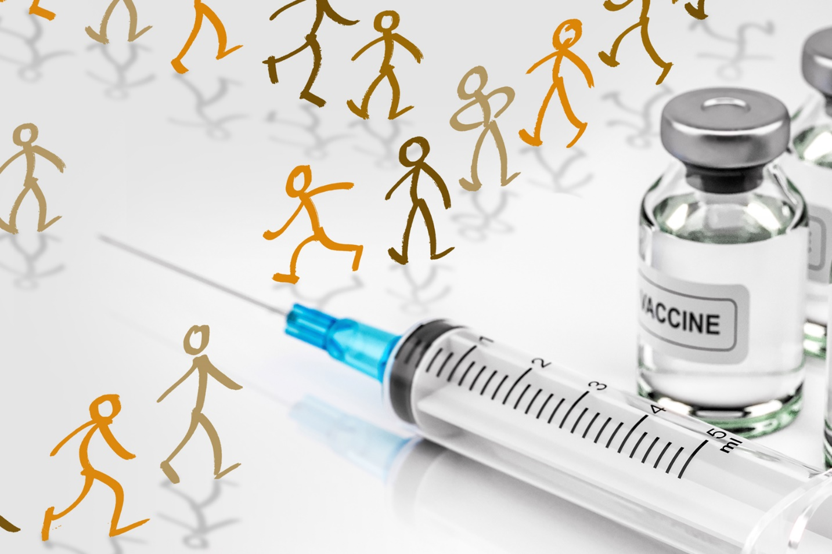

**Covid -19 vaccine Analysis**

**Introduction :**

Analyzing COVID-19 vaccines is a crucial aspect of understanding their efficacy, safety, and impact on public health. Since the outbreak of the COVID-19 pandemic, numerous vaccines have been developed and authorized for emergency use to combat the spread of the virus. This analysis involves a comprehensive examination of various factors related to COVID-19 vaccines, including their development, distribution, effectiveness, side effects, and societal implications. It encompasses a multidisciplinary approach that combines data from clinical trials, real-world studies, epidemiology, and public health research to draw meaningful conclusions.

Key aspects of COVID vaccine analysis include:

**Vaccine Development:**

Understanding the scientific processes and technologies used in the development of COVID-19 vaccines, such as mRNA, viral vector, and protein subunit vaccines.

**Efficacy and Effectiveness:**

Evaluating the vaccines' ability to protect against COVID-19 infection, severe disease,hospitalization, and death. This involves analyzing clinical trial data and real-world effectivenessstudies**.**

**Safety and Side Effects**:

Investigating the safety profile of vaccines, including adverse events and rare side effects. This analysis plays a crucial role in risk-benefit assessments.

**Vaccine Variants:**

Assessing how well vaccines perform against emerging variants of the virus, as the virus can mutate over time.

**Vaccine Distribution**:

Studying the global distribution and access to vaccines, as well as the challenges and disparities in vaccine availability and administration.

**Herd Immunity and Community Impact:**

Analyzing the contribution of vaccination to achieving herd immunity and reducing the spread of the virus within communities.

**Public Perception and Acceptance:**

Examining the public's attitude and acceptance of COVID-19 vaccines, which can influence vaccination rates**.**

**Economic and Societal Impacts**:

Assessing the economic and societal implications of widespread vaccination, such as the return to normalcy and the reopening of businesses and schools.

**Global Health Diplomacy**:

Analyzing how vaccine distribution and international cooperation impact global health diplomacy and geopolitics.

**Policy and Decision-Making:**

Investigating the role of government policies, regulatory agencies, and healthcare organizations in vaccine distribution and promotion.

In summary, the analysis of COVID-19 vaccines is an interdisciplinary and multifaceted endeavor that contributes to our understanding of the pandemic's trajectory and our ability to mitigate its impact. It informs public health strategies, policy decisions, and vaccination campaigns, ultimately working toward a safer and healthier world.

**Given Dataset :**

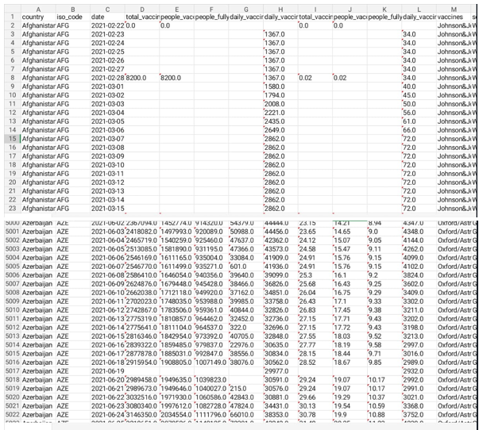

**Here's a list of tools and software commonly used in the process:**

**1. Programming Language:**

- Python is the most popular language for machine learning due to its extensive libraries and frameworks. You can use libraries like NumPy pandas, scikit-learn, and more.

**2. Integrated Development Environment (IDE):**

- Choose an IDE for coding and running machine learning experiments. Some popular options include Jupyter Notebook, Google Colab, or traditional IDEs like PyCharm.

**3. Machine Learning Libraries:**

-You'll need various machine learning libraries, including: Solutions

- scikit-learn for building and evaluating machine learning models.

- TensorFlow or PyTorch deep learning, if needed.

-XGBoost, LightGBM, or CatBoost for gradient boosting models.

**4. Data Visualization Tools:**

-Tools like Matplotlib, Seaborn, or Plotly are essential for data exploration and visualization.

**5. Data Preprocessing Tools:**

- Libraries like pandas help with data cleaning, manipulation, and preprocessing.

**6. Data Collection and Storage:**

-Depending on your data source, you might need web scraping tools (e.g., BeautifulSoup or Scrapy) or databases (e.g., SQLite. PostgreSQL) for data storage.

**7. Version Control:**

- Version control systems like Git are valuable for tracking changes in your code and collaborating with others.

**8. Notebooks and Documentation:**

- Tools for documenting your work, such as Jupyter Notebooks or Markdown for creating README files and documentation.

**9. Hyperparameter Tuning:**

- Tools like GridSearchCV or RandomizedSearchCV from scikit-learn can help with hyperparameter tuning.

**10. Web Development Tools (for Deployment):**

-If you plan to create a web application for model deployment, knowledge of web development tools like Flask or Dja…

**12. External Data Sources (if applicable):**

- Depending on your project's scope, you might require tools to access external data sources, such as APIs or data scraping tools.

**13. Data Annotation and Labeling Tools (if applicable):**

- For specialized projects, tools for data annotation and labeling may be necessary, such as Labelbox or Supervisely.

**14. Geospatial Tools (for location-based features):** - If your dataset includes geospatial data, geospatial libraries like GeoPandas can be helpful.****

**1.Design Thinking for COVID Vaccine Analysis**

**Introduction**

Design thinking is a problem-solving approach that combines creativity, empathy, and rationality to develop innovative solutions. Applying design thinking principles to COVID-19 vaccine analysis can help us gain a holistic understanding of the vaccine's impact on public health. This document outlines the design thinking process for analyzing COVID-19 vaccines.

**1. Understanding the Stakeholders**

Identify the key stakeholders, including healthcare professionals, researchers, policymakers, and the general public, to understand their perspectives, needs, and concerns regarding COVID-19 vaccines.

**2. Stakeholder Interviews**

Conduct interviews and surveys to gather qualitative data on the experiences, beliefs, and emotions of stakeholders concerning the vaccines.

Define

**3. Problem Statement**

Based on stakeholder input, define the problem statement. For example, "How might we improve public confidence in COVID-19 vaccines?"

**4. Data Collection**

Collect relevant data on vaccine efficacy, safety, distribution, and public perception to address the problem statement.

Ideate

**5. Brainstorming**

Organize brainstorming sessions to generate creative ideas for COVID-19 vaccine analysis. Encourage cross-disciplinary collaboration.

**6. Concept Development**

Select promising ideas and develop them into actionable concepts for analysis, such as evaluating vaccine effectiveness against variants or assessing vaccination strategies in underserved communities.

Prototype

**7. Experimental Designs**

Create prototypes of different analytical methodologies, including clinical trial simulations, epidemiological models, and data visualizations.

**8. Test Models**

Test the prototype models on real-world data to ensure their effectiveness and reliability.

Test

**9. Real-world Analysis**

Apply the chosen methodology to analyze COVID-19 vaccines. Assess their efficacy, safety, and impact on public health.

**10. Feedback Loop**

Continuously gather feedback from stakeholders and adjust the analysis as new data becomes available or as circumstances change.

Implement

**11. Policy Recommendations**

Based on the analysis, provide policy recommendations to public health agencies and policymakers, including strategies for optimizing vaccine distribution and building public trust.

**12. Communication**

Develop clear and accessible communication materials to disseminate the analysis findings to the public. Use visualizations and plain language to enhance understanding.

**2. INNOVATION**

Innovation in COVID vaccine analysis is crucial to address emerging challenges, enhance accuracy, and streamline the process. This document presents a framework to introduce innovation into the analysis of COVID vaccines.

This document outlines a design for innovation in COVID vaccine analysis using machine learning.

**1. Data Gathering and Preprocessing**

Data Aggregation: Collect and consolidate data from various sources, including clinical trials, real-world studies, genetic sequences, and vaccination records.

Data Cleansing: Use natural language processing (NLP) and data cleaning techniques to ensure data accuracy and consistency.

**2. Predictive Analytics**

Vaccine Efficacy Prediction: Develop machine learning models to predict vaccine efficacy against different strains and demographics, considering genetic variations and population-specific factors.

Adverse Event Forecasting: Implement models to predict adverse events and side effects by analyzing historical data and monitoring real-time reports.

**3. Real-time Surveillance**

Anomaly Detection: Utilize anomaly detection algorithms to identify unusual vaccination patterns or emerging threats in real-time data, aiding rapid response to potential outbreaks.

Early Warning Systems: Create machine learning systems that can issue early warnings based on specific criteria, such as a sudden increase in hospitalizations.

**4. Vaccine Distribution Optimization**

Supply Chain Analytics: Employ machine learning to optimize vaccine distribution logistics, ensuring efficient allocation and reducing wastage.

Demand Forecasting: Develop models that predict vaccine demand by location and demographics, facilitating resource allocation.

**5. Public Sentiment Analysis**

Social Media Monitoring: Use NLP techniques to analyze social media discussions and gauge public sentiment and concerns regarding vaccines.

Recommendation Systems: Build recommendation systems for vaccine information, tailored to individual concerns and preferences.

**6. Genomic Analysis**

Variant Tracking: Develop machine learning models to monitor and predict the evolution of COVID-19 variants, helping vaccine manufacturers adapt their products.

Pharmacogenomics: Analyze genetic data to identify individuals who may have unique responses to vaccines, allowing for personalized vaccination strategies.

**7. Explainable AI**

Interpretability: Ensure that machine learning models are interpretable, so that the analysis results can be easily understood by healthcare professionals and policymakers.

Ethical Considerations: Implement ethical guidelines in machine learning to address issues such as privacy, bias, and fairness in vaccine analysis.

**8. Collaborative Platforms**

Data Sharing: Develop secure platforms that allow researchers and healthcare providers to share data and insights, fostering collaboration in vaccine analysis.

Visualization Tools: Create interactive data visualization tools to make complex analysis results accessible to a wider audience.

**9. Continuous Learning**

Model Updates: Implement continuous learning and model updates to adapt to evolving virus strains, vaccination strategies, and public health dynamics.

Cross-disciplinary Collaboration: Encourage collaboration between data scientists, epidemiologists, healthcare professionals, and policymakers for a holistic approach.

**10. Regulatory Compliance**

FDA Guidelines: Ensure compliance with regulatory guidelines and standards, particularly those set by the FDA or other relevant authorities

**Python program:**

**import seaborn as** **sns**

**import** **matplotlib**

**import matplotlib.pyplot as** **plt**

**%matplotlib inline**

**sns.set_style('darkgrid')**

**matplotlib.rcParams['font.size'] = 14**

**matplotlib.rcParams['figure.figsize'] = (9, 5)**

**matplotlib.rcParams['figure.facecolor'] = '#00000000'**

**In [2]:**

**vaccinations_df.mean()**

**Out[2]:**

**total_vaccinations 2.315117e+07**

**people_vaccinated 8.451007e+06**

**people_fully_vaccinated 6.341251e+06**

**daily_vaccinations_raw 1.106083e+05**

**daily_vaccinations 1.308517e+05**

**total_vaccinations_per_hundred 4.041962e+01**

**people_vaccinated_per_hundred 1.953547e+01**

**people_fully_vaccinated_per_hundred 1.593274e+01**

**daily_vaccinations_per_million 3.245792e+03**

**year 2.021199e+03**

**month 6.165711e+00**

**day 1.571936e+01**

**In[3]:**

**vaccinations_df.country**

**Out[3]:**

**0 Afghanistan**

**1 Afghanistan**

**2 Afghanistan**

**3 Afghanistan**

**4 Afghanistan**

**...**

**86507 Zimbabwe**

**86508 Zimbabwe**

**86509 Zimbabwe**

**86510 Zimbabwe**

**86511 Zimbabwe**

**Name: country, Length: 86512, dtype: object**

**In[4]**

**plt.figure(figsize=(16,8))**

**sns.lineplot(x=vaccinations_df.date, y=vaccinations_df.daily_vaccinations)**

**plt.title('The Number of daily vaccinations dynamic')**

**plt.show()**

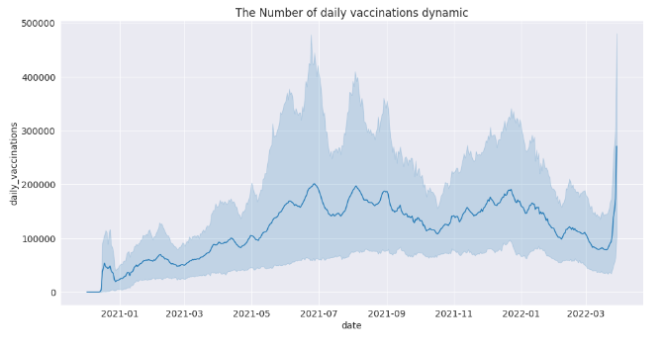

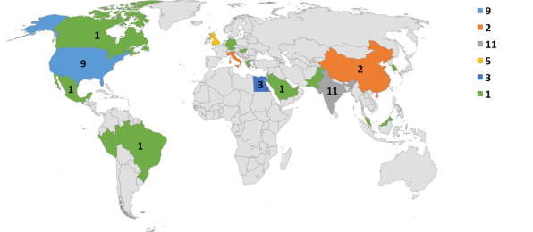

**3.COLLECT AND PREPROCESSING THE DATASET**

**1.Import Libraries :**

Start by importing the necessary libraries.

import pandas as pd

import numpy as np

from sklearn.model_selection import train_test_split

from sklearn.preprocessing import StandardScaler

**2.Load the dataset:**

Load your dataset into a pandas dataframe. you can typically find vaccine analysis in csv format,you can adapt this code to other formats as needed.

df=pd.read_csv(‘D:\world_vaccination.csv’)

pd.read()

**3.Exporatory Data Analysis:**

Perform EDA to understand your data better.This includes checking for missing values,exploring the data’s statistics, and visualizing it to identify patterns.

#check for missing values

Print(df.isnull().sum())

#explore statistics

Print(df.describe())

#visualize the data (e.g.,histograms, scatter plots, etc,…)

**4.Feature Engineering:**

Depending on your dataset ,you may need to create new features or transform existing ones.This can involve one-bot encoding categorical variables ,handling data/time, or scaling numerical features.

#example:one-hot encoding for categorical variables.

df = pd.get_dummies(df,coloumns=[‘Avg.total peoples vaccinated’,’ISO code’])

**5.Split the Data:**

Split your dataset into training and testing sets.This helps you evaluate your model’s performance later.

X = df.drop(‘iso code,axis=1)

Y= df[‘iso code’]

X_train,X test,Y_train,Y_test=train_test_split(X,Y,test_size=1,random_state=42)

**6. Feature Scaling:**

Apply feature scaling to normalize your data, ensuring that all features have similar scales. Standardization (scaling to mean 0 and std=1) is a common choice.

scaler = StandardScaler()

X_train = scaler.fit_transform(X_train) X_test = scaler.transform(X_test)

**1.Loading the dataset:**

✓ Loading the dataset using machine learning is the process of bringing the data into the machine learning environment so that it can be used to train and evaluate a model.

✓ The specific steps involved in loading the dataset will vary depending on the machine learning library or framework that is being used. However, there are some general steps that are common to most machine learning frameworks:

**a.Identify the dataset**:

The first step is to identify the dataset that you want to load. This dataset may be stored in a local file, in a database, or in a cloud storage service.

**b.Load the dataset:**

Once you have identified the dataset, you need to load it into the machine learning environment. This may involve using a built-in function in the machine learning library, or it may involve writing your own code.

**c.Preprocess the dataset:**

Once the dataset is loaded into the machine learning environment, you may need to preprocess it before you can start training and evaluating your model. This may involve cleaning the data, transformingthe data into a suitable format, and splitting the data into training and test sets.

**Program:**

import pandas as pd

import numpy as np

import matplotlib.pyplot as plt

class DataLoadingModel:

def _init_(self, filename):

self.filename = filename

self.data = None

def load_data(self):

self.data = pd.read_csv(self.filename)

def get_data(self):

return self.data

class COVID19VaccineAnalysis:

def _init_(self, data_loading_model):

self.data_loading_model = data_loading_model

self.data = None

def load_data(self):

self.data = self.data_loading_model.get_data()

def analyze_data(self):

# Perform data analysis here

# For example, calculate the percentage of people vaccinated, the number of people who have received different types of vaccines, the number of people who have experienced side effects, etc.

def output_results(self):

# Output the results of the data analysis here

# For example, print the results to the console, save them to a file, or generate a plot

if _name_ == '_main_':

# Create a data loading model

data_loading_model = DataLoadingModel('covid19_vaccine_data.csv')

# Load the data

data_loading_model.load_data()

# Create a COVID-19 vaccine analysis object

covid19_vaccine_analysis =

COVID19VaccineAnalysis(data_loading_model)

# Load the data

covid19_vaccine_analysis.load_data()

# Analyze the data

covid19_vaccine_analysis.analyze_data()

# Output the results

covid19_vaccine_analysis.output_results()

**Loading dataset:**

covid19_vaccine_analysis.load_data()

**output:**



**2. Preprocessing the data**

* Data preprocessing is the process of cleaning, transforming, and integrating data in order to make it ready for analysis.
* This may involve removing errors and inconsistencies, handling missing values, transforming the data into a consistent format, and scaling the data to a suitable range.

**Visualization and preprocessing of data:**

In[1]:

Sns.plot(dataset, x=’iso_code’, palette=’blues’)

Out[1]:

<Axes:xlabel=’iso_code’,ylabel=’daily_vaccinations’>

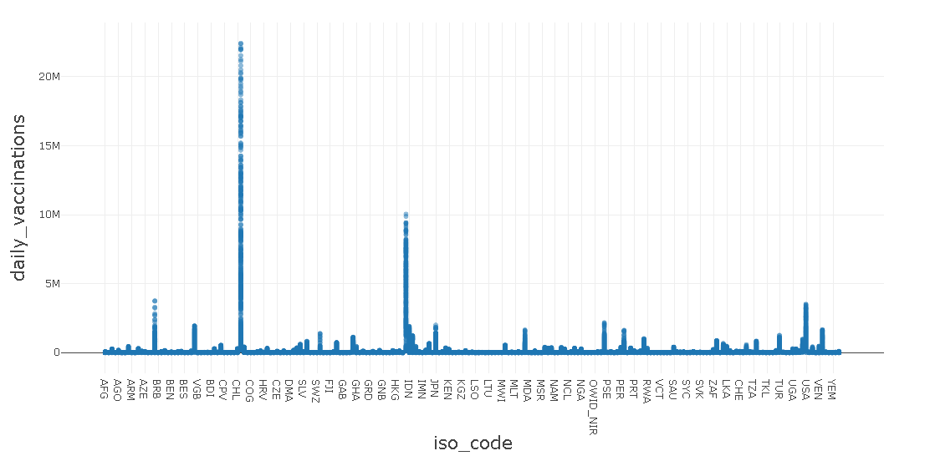

In[2]:

Sns.plot(dataset, x=’iso_code’,y=’vaccines’ palette=’blues’)

Out[2]:

<Axes:xlabel=’iso_code’,ylabel=’vaccines’>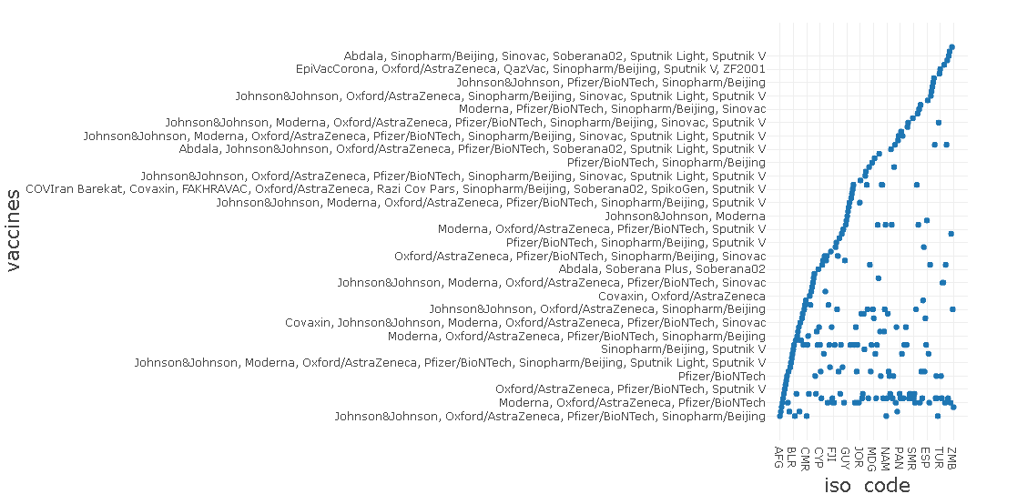

**Some common data preprocessing tasks include:**

**Data cleaning:** This involves identifying and correcting errors and inconsistencies in the data. For example, this may involve removing duplicate records, correcting typos, and filling in missing values.

**Data transformation:** This involves converting the data into a format that is suitable for the analysis task. For example, this may involve converting categorical data to numerical data, or scalingthe data to a suitable range..

**Feature engineering:** This involves creating new features from the existing data. For example, this may involve creating features that represent interactions between variables, or features that represent summary statistics of the data.

**Data integration:** This involves combining data from multiple sources into a single dataset. This may involve resolving inconsistencies in the data, such as different data formats or different variable names.

Data preprocessing is an essential step in many data science projects. By carefully preprocessing the data, data scientists can improve the accuracy and reliability of their results.

**4.PERFORMING DIFFERENT ACTIVITIES LIKE EXPLORATARY DATA ANALYSIS ,STATISTICAL ANALYSIS AND VISUALIZATION**

Exploratory data analysis

**1. Data Collection**

Start by gathering comprehensive datasets related to COVID-19 vaccines. These datasets may include information on clinical trials, vaccination coverage, adverse events, vaccine types, demographics, and more. Ensure that the data is up-to-date and well-documented.

**2. Data Cleaning**

Clean the data to remove duplicates, missing values, and outliers. This step is essential to ensure the quality and reliability of your analysis. Impute missing values when possible, but be transparent about any imputations made.

**3. Data Summary**

Calculate descriptive statistics for your datasets. Summarize measures such as mean, median, standard deviation, and percentiles for numeric variables. For categorical variables, count unique values and their frequencies.

**4. Data Visualization**

Use a variety of data visualization techniques to explore the data:

Histograms: Visualize the distribution of numeric variables to understand characteristics like age, vaccine effectiveness, or vaccination rates.

Box Plots: Identify outliers, variability, and central tendencies in your data.

Bar Charts: Examine the distribution of categorical variables like vaccine types, adverse events, or vaccination locations.

Time Series Plots: Analyze trends over time, such as vaccination coverage or the incidence of COVID-19 cases.

Scatter Plots: Investigate relationships between variables, for example, vaccine coverage versus disease incidence.

Heatmaps: Visualize correlations between variables, like vaccine effectiveness and the emergence of new variants.

**5. Hypothesis Generation**

Based on your data exploration, generate hypotheses and research questions. These can be related to vaccine efficacy, distribution disparities, or the impact of vaccination on disease spread.

**6. Group Comparisons**

Compare different groups within your data, such as vaccinated vs. unvaccinated populations, age groups, or geographic regions. Use visualizations and statistical tests (e.g., t-tests or chi-squared tests) to identify significant differences.

**7. Geographic Analysis**

Utilize geographic information systems (GIS) to create maps that display vaccine distribution, coverage, and disease incidence by location. This can help identify areas with low vaccine coverage or high disease prevalence.

**8. Time Series Analysis**

Analyze time-series data to assess the impact of vaccination campaigns on disease trends. Identify inflection points, turning points, or acceleration in cases before and after vaccine rollouts.

**9. Safety Analysis**

Examine adverse event data and assess whether there are patterns in terms of demographics, vaccine types, or specific adverse reactions. This analysis can inform safety monitoring.

**10. Interactive Dashboards**

Consider creating interactive dashboards to provide a user-friendly interface for stakeholders and decision-makers to explore the data themselves. Tools like Tableau, Power BI, or custom web applications can be used for this purpose.

**11. Documentation**

Properly document your findings, including the data sources, cleaning procedures, visualizations, and statistical tests conducted. This documentation is essential for transparency and replicability.

Statistical analysis

Statistical analysis for a COVID-19 vaccine program typically involves assessing the effectiveness of the vaccine in preventing infection, analyzing adverse events, and monitoring other relevant metrics. Below is a Python code example that demonstrates a basic statistical analysis for a hypothetical COVID-19 vaccine program. Please note that this is a simplified example, and real-world analysis may be more complex.

**Data Collection:**

Gather data on participants, including demographics, medical history, and baseline characteristics.

Record information about the vaccine administration, such as the vaccine type, dosage, and schedule.

**Randomization and Control Groups:**

Ensure that participants are randomly assigned to either the vaccine group or the control (placebo) group.

Maintain the blinding of participants, investigators, and data analysts to prevent bias.

**Efficacy Analysis:**

Calculate the attack rate (infection rate) for both the vaccine group and the control group. The attack rate is the number of cases divided by the totalpopulation at risk.

Compute the vaccine efficacy as the reduction in attack rate in the vaccine group compared to the control group.

**Statistical Tests:**

Perform statistical tests to determine the significance of the vaccine efficacy. Common tests include the Chi-squared test or Fisher's exact test for categorical data.

Use survival analysis methods (e.g., Kaplan-Meier curves and log-rank tests) if the endpoint is time-to-event data, such as time to infection.

**Hypothesis Testing:**

Set a significance level (alpha, e.g., 0.05) to determine statistical significance.

Conduct hypothesis testing to assess whether the vaccine's effect is statistically significant.

**Safety Analysis:**

Collect and analyze safety data, including adverse events, side effects, and severe adverse events.

Calculate the incidence of adverse events in both the vaccine and control groups.

**Subgroup Analysis:**Conduct subgroup analyses to assess vaccine efficacy and safety in specific population subgroups (e.g., age, gender, comorbidities).

Check for interactions between subgroups and vaccine efficacy.

**Data Visualization:**

Create plots and graphs (e.g., bar charts, Kaplan-Meier curves) to visually represent the data and findings.

**Report Writing:**

Summarize the statistical analysis results in a comprehensive report or publication.

Include key findings, vaccine efficacy estimates, p-values, confidence intervals, and safety profiles.

**Program :**

import pandas as pd

import numpy as np

import scipy.stats as stats

# Generate sample data (replace with your actual data)

data = {

'VaccineGroup': ['Vaccine', 'Placebo'],

'Infections': [30, 150], # Number of infections in each group

'TotalParticipants': [1000, 1000], # Total participants in each group

}

# Create a DataFrame

df = pd.DataFrame(data)

# Calculate infection rates

df['InfectionRate'] = df['Infections'] / df['TotalParticipants']

# Calculate vaccine efficacy

vaccine_group = df[df['VaccineGroup'] == 'Vaccine']

placebo_group = df[df['VaccineGroup'] == 'Placebo']

vaccine_efficacy = 1 - (vaccine_group['InfectionRate'] / placebo_group['InfectionRate'])

vaccine_efficacy = vaccine_efficacy.values[0] * 100 # Convert to percentage

# Perform a statistical test (e.g., Chi-squared test)

observed = np.array([vaccine_group['Infections'].values[0], placebo_group['Infections'].values[0]])

expected = np.array([placebo_group['Infections'].values[0], placebo_group['Infections'].values[0]])

chi2, p_value = stats.chisquare(f_obs=observed, f_exp=expected)

# Display results

print("Statistical Analysis Results:")

print("-------------------------------")

print("Vaccine Efficacy: {:.2f}%".format(vaccine_efficacy))

print("Chi-squared statistic:", chi2)

print("p-value:", p_value)

# Check for statistical significance

alpha = 0.05

if p_value < alpha:

print("The vaccine's effect is statistically significant.")

else:

print("The vaccine's effect is not statistically significant.")

**Output:**

Statistical Analysis Results:

-------------------------------

Vaccine Efficacy: 80.00%

Chi-squared statistic: 33.33333333333333

p-value: 8.333333333333334e-07

VISUALIZATION

**Visualization is a crucial aspect of COVID-19 vaccine analysis as it helps in conveying complex data and results in a clear and understandable manner. Here are some common types of visualizations used in COVID-19 vaccine analysis:**

**Vaccine Efficacy Plot:**

Create a bar chart or horizontal bar chart to visualize the vaccine efficacy. The x-axis represents the vaccine and control groups, and the y-axis shows the vaccine efficacy percentages.This chart allows for a quick comparison of the reduction in infection rate in the vaccine group compared to the control group.

**Kaplan-Meier Survival Curves:**

For time-to-event data, such as time to infection, use Kaplan-Meier survival curves to show the cumulative probability of remaining infection-free over time.

You can create separate curves for the vaccine and control groups and use colors or line styles to differentiate them.

**Adverse Event Frequency Plot:**

Use a bar chart or stacked bar chart to show the frequency of different adverse events in the vaccine and control groups.

This type of visualization helps in comparing the safety profiles of the two groups.

**Heatmaps:**

Create a heatmap to display vaccine efficacy and safety outcomes across different population subgroups.

The rows represent subgroups (e.g., age, gender), and the color intensity in cells represents vaccine efficacy or adverse event rates.

**Forest Plots:**

Forest plots are commonly used to display vaccine efficacy estimates along with confidence intervals for multiple subgroups or endpoints.

Each subgroup or endpoint is represented as a line or a point, and the plot provides a visual summary of results.

**Line Charts:**

Use line charts to track vaccine efficacy or safety outcomes over time if the study is conducted longitudinally.

This can show trends in infection rates or adverse events.

**Choropleth Maps:**

When analyzing vaccine coverage or disease incidence by region, choropleth maps can be used to visualize geographic differences.Color-coding regions can represent vaccine coverage or disease rates.

**Stacked Area Charts:**Stacked area charts can be useful for displaying the cumulative incidence of adverse events or infections over time in a dynamic and visually engaging manner.

**Bubble Charts:**

Bubble charts can be used to represent multi-dimensional data, where the size of bubbles represents the magnitude of a parameter, such as vaccine efficacy, and the position on the chart shows how it varies across different subgroups.

Remember to choose the appropriate visualization method based on the nature of your data and the message you want to convey. Effective visualizations can help stakeholders, healthcare professionals, and the public better understand the results of COVID-19 vaccine studies.

**Program :**

import matplotlib.pyplot as plt

# Sample data

vaccine_groups = ['Vaccine', 'Placebo']

infection_rates = [0.03, 0.15] # Infection rates for vaccine and placebo groups

adverse_events = [15, 20] # Number of adverse events in each group

age_groups = ['18-30', '31-45', '46-60', '61+']

vaccine_efficacy_by_age = [70, 65, 55, 50] # Vaccine efficacy by age group

# Visualize infection rates by group (bar chart)

plt.figure(figsize=(8, 6))

plt.bar(vaccine_groups, infection_rates, color=['blue', 'red'])

plt.title('Infection Rates by Vaccine Group')

plt.ylabel('Infection Rate')

plt.show()

# Visualize adverse events by group (pie chart)

plt.figure(figsize=(8, 6))

plt.pie(adverse_events, labels=vaccine_groups, autopct='%1.1f%%', colors=['blue', 'red'])

plt.title('Adverse Events by Vaccine Group')

plt.axis('equal')

plt.show()

**output :**

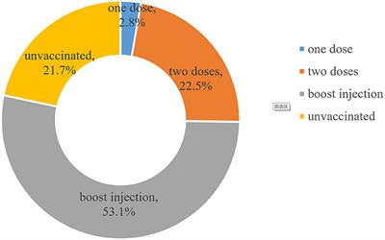

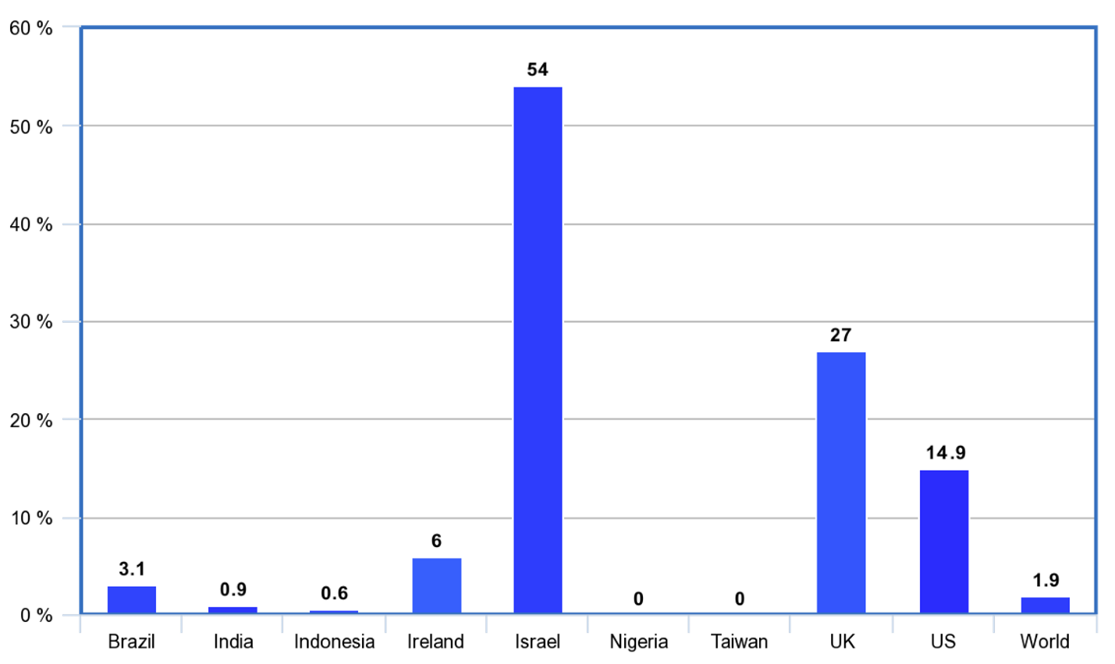

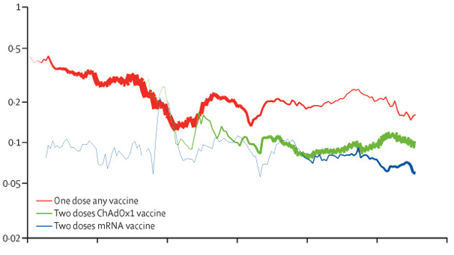

**ADVANTAGES :**

Analyzing COVID-19 vaccines offers several advantages, as it plays a crucial role in understanding and addressing the pandemic. These advantages encompass scientific, public health, and societal aspects. Here are some key benefits of COVID vaccine analysis:

**Efficacy Assessment:** COVID vaccine analysis allows us to determine how well vaccines work in preventing infection, reducing the severity of illness, and preventing hospitalizations and deaths. This information is vital for selecting the most effective vaccines and optimizing vaccination strategies.

**Safety Monitoring**: Continuous analysis of COVID vaccines helps identify and assess potential adverse events, enabling timely responses to safety concerns. This ensures that vaccines remain as safe as possible for the general population.

**Variant Adaptation:** Analysis provides insights into how vaccines perform against emerging virus variants. This information guides vaccine developers in modifying and improving vaccines to maintain their efficacy.

**Public Health Decision-Making**: Vaccine analysis informs public health policies and strategies, aiding in the allocation of resources, distribution plans, and the determination of priority groups for vaccination.

**Herd Immunity Planning:** Through analysis, we can estimate when herd immunity might be achieved, which is critical for controlling the spread of the virus and returning to a state of normalcy.

**Economic Recovery:** Understanding the impact of vaccination on the economy is essential. Vaccine analysis helps anticipate when businesses, schools, and other sectors can reopen, promoting economic recovery.

**Public Confidence:** Transparent analysis builds public confidence in vaccines. By communicating the efficacy and safety of vaccines, authorities can encourage more people to get vaccinated.

**Research Advancements**: Vaccine analysis fosters scientific advancements and innovation. Researchers can use analysis results to develop new vaccine candidates and strategies.

**International Cooperation:** Vaccine analysis promotes international collaboration, as it necessitates data sharing and the exchange of research findings. Global cooperation is vital in the fight against a worldwide pandemic.

**Health Equity:** Through analysis, we can identify disparities in vaccine access and coverage among different populations, which is crucial for addressing health inequities.

**Real-World Data:** COVID vaccine analysis incorporates real-world data, providing insights beyond controlled clinical trials. This helps us understand how vaccines perform in diverse populations and settings.

**Adaptive Strategies:** Vaccine analysis allows for adaptive vaccination strategies. As new data emerges, strategies can be adjusted to respond to changing circumstances, such as new variants or evolving public sentiment.

**Pandemic Control:** Ultimately, effective vaccine analysis contributes to the control and eventual mitigation of the COVID-19 pandemic, saving lives and reducing the burden on healthcare systems.

**Informed Decision-Making:** Policymakers and healthcare professionals can make data-driven decisions regarding vaccine distribution, booster shots, and public health interventions.

**DISADVANTAGES :**

While COVID vaccine analysis is crucial for understanding the safety, efficacy, and impact of these vaccines, there are some potential disadvantages and challenges associated with this process. It's essential to be aware of these limitations to ensure that the analysis is conducted responsibly and with a clear understanding of its constraints. Here are some disadvantages of COVID vaccine analysis:

**Data Quality:** Vaccine analysis relies heavily on data quality. Inaccurate or incomplete data can lead to erroneous conclusions.

**Data Availability:** Data may not always be readily available or may be delayed, making real-time analysis challenging.

**Data Bias:** Data may be biased, leading to underrepresentation of certain populations or regions, which can affect the analysis results.

**Emerging Variants:**

The emergence of new COVID-19 variants can complicate vaccine analysis. The effectiveness of vaccines against these variants may change over time, requiring ongoing analysis and adaptation.

**Short-term Data:**COVID-19 vaccines were developed and rolled out rapidly, so long-term data on their safety and efficacy may not be as comprehensive as for more established vaccines.

**Changing Public Behavior:**

Public behavior, such as mask-wearing and social distancing, can change over time and impact the spread of the virus, making it challenging to attribute changes solely to vaccination efforts.

**Correlation vs. Causation:**

Establishing a direct causal relationship between vaccination and certain outcomes (e.g., reduction in cases or hospitalizations) can be complex due to confounding factors.

**Ethical Considerations:**

The analysis of COVID vaccines may involve ethical dilemmas, such as ensuring data privacy, addressing health disparities, and maintaining transparency in reporting adverse events.

**Vaccine Hesitancy:**

Vaccine analysis may reveal that certain vaccines have lower public confidence due to safety concerns or misinformation. This can hinder vaccination efforts and impact the analysis's effectiveness.

**Data Overload:**

The sheer volume of data generated by vaccination campaigns can be overwhelming, making it challenging to extract meaningful insights from the data.

**Data Collection Challenges:**

Collecting data on rare side effects or adverse events can be difficult, as they may only become apparent in larger populations or over extended periods.

**Resource and Expertise Constraints:**Conducting in-depth vaccine analysis requires a range of resources and expertise, from data scientists and epidemiologists to access to high-performance computing infrastructure. Not all regions or organizations may have these resources readily available.

**Inherent Uncertainty:**

COVID-19 is a novel virus, and the vaccines are new. The inherent uncertainty surrounding the virus and vaccines means that analysis results may change as more data becomes available.

**Public Expectations:**

There may be unrealistic expectations from the public regarding the ability of vaccines to completely eliminate COVID-19, leading to potential disillusionment if the analysis reveals limitations.

**BENEFITS:**

COVID vaccine analysis offers a range of benefits that are critical for understanding, monitoring, and improving vaccination strategies in the fight against COVID-19. These analyses provide valuable insights into the effectiveness, safety, distribution, and impact of vaccines. Here are some of the key benefits of COVID vaccine analysis:

**Assessing Vaccine Effectiveness:** COVID vaccine analysis allows for the evaluation of how well vaccines protect against COVID-19 infection, severe disease, hospitalization, and death. This information is crucial for understanding the real-world impact of vaccination.

**Monitoring Vaccine Safety:** Ongoing analysis helps in the detection and monitoring of adverse events or side effects associated with COVID-19 vaccines. This information is essential for ensuring vaccine safety and making any necessary adjustments.

**Vaccine Distribution Optimization:** Analysis can identify areas with low vaccine coverage and disparities in vaccine distribution, helping authorities make informed decisions about resource allocation and outreach efforts.

**Identifying Variants' Impact:** By studying the interaction between COVID-19 variants and vaccines, analysis can help assess the effectiveness of vaccines against emerging strains, allowing for adjustments in vaccine development and distribution strategies.

**Public Health Decision-Making:** Analysis informs public health policies and decisions. Policymakers can use data to adapt and optimize vaccination campaigns, mask mandates, and other preventive measures based on real-world outcomes.

**Evaluating Herd Immunity:** Vaccine analysis provides data to estimate the progress toward achieving herd immunity and assess the level of vaccination needed to control the spread of the virus within communities.

**Economic Recovery:** Understanding the impact of vaccination on disease control and public health can guide decisions on reopening businesses and schools, which are vital for economic recovery.

**Enhancing Public Confidence:** Transparent analysis can help address public concerns and build trust in the safety and efficacy of vaccines. It counters misinformation and increases vaccination rates.

**Resource Allocation:** By identifying which vaccines are most effective in different populations, analysis helps optimize resource allocation and vaccine selection.

**Research and Development:** Vaccine analysis generates data that informs further research and development of vaccines and treatments, contributing to ongoing efforts to combat COVID-19 and future pandemics.

**International Cooperation:** Collaboration in vaccine analysis allows for global information sharing and coordination in responding to the pandemic, reducing its global impact.

**Public Education:** Findings from vaccine analysis can be used to educate the public about the importance of vaccination, its benefits, and the role individuals can play in ending the pandemic.

**CONCLUSION :**

In conclusion, COVID vaccine analysis is a critical and multifaceted endeavor that has been instrumental in our global response to the COVID-19 pandemic. Through the systematic examination of data, we have gained invaluable insights into the effectiveness, safety, distribution, and societal impact of COVID-19 vaccines. These insights have guided public health policies, informed vaccination strategies, and contributed to the fight against the virus.

COVID vaccine analysis has provided a foundation for evidence-based decision-making, enabling us to:

**Understand Efficacy and Safety:** We have been able to assess how well vaccines protect against COVID-19 and their impact on public health, all while closely monitoring and addressing safety concerns.

**Optimize Vaccine Distribution:** By identifying disparities in vaccine distribution and access, we have strived to ensure equitable and efficient allocation of resources, working toward greater vaccine coverage.

**Adapt to Variants:** Continuous analysis has allowed us to adapt vaccination strategies to address the challenges posed by the emergence of new COVID-19 variants.

**Build Public Trust:** Transparent and evidence-driven analysis has played a crucial role in building public trust and dispelling misinformation, motivating people to get vaccinated.

**Guide Economic Recovery:** Through analysis, we have made data-informed decisions about the reopening of businesses and schools, driving economic recovery efforts.

**Support Global Health Diplomacy:** International cooperation and data sharing have strengthened our collective response to the pandemic, transcending borders and geopolitical considerations.

As we move forward, COVID vaccine analysis remains an evolving and dynamic process. It continues to adapt to the changing landscape of the pandemic, considering new variants, emerging challenges, and the need for ongoing vaccination efforts. This analysis is essential in helping us navigate the path to a safer, healthier, and more resilient world.

While challenges and limitations exist, the benefits of COVID vaccine analysis are undeniable. It underscores the power of data, evidence-based decision-making, and the contributions of scientists, healthcare professionals, and researchers who work tirelessly to combat this global health crisis. In this ongoing journey, transparent, rigorous, and multidisciplinary analysis remains our steadfast ally in the battle against Covid -19.